# ATS – Asia Ticketing Script

# User Guide

Version No: 12.0

# Prepared by: Nikki Bromwich

# Date: 28 February 2012

Table of Contents

Purpose of the Document 3

Overview 3

Other Notes in the Agency Private Fares Contract 3

Accessing ATS 4

Navigation within the Script 4

Name Screen 5

Passenger Selection 5

Adding/Amending a PTC 6

Adding/Amending a child age 7

Flights Screen 8

Flight Selection 9

Fare Quote Modifiers 10

Fare Option Screen 12

Fare Alternative 12

Combination Fares 13

Update Screen 15

Flight Data 16

Ticket Modifiers 16

Confirm Screen 19

PNR 20

# Purpose of the Document

This document is the User Guide for ATS – Asia Ticketing Script V12.0. It describes in detail the steps involved to use the script. All examples in the guide are for illustrative purposes only.

# Overview

ATS is a ticketing script specifically designed for use in specific Asian countries. It provides a simple-to-use graphical user interface (GUI) and is accessed through an icon on the viewpoint custom toolbar from either Focalpoint or Viewpoint.

ATS automates the quoting and pre-ticketing process for Agency Private Fares by allowing the Travel Agent to manipulate the fare data according to special codes loaded into the OTHER NOTES section of the APF contract & also by information inputted by the agent, through the ATS GUI itself.

# Other Notes in the Agency Private Fares Contract

ATS is used in conjunction with fares loaded through APF, as it relies on data filed in the OTHER NOTES section of the contract to determine how to quote the fare. For a full description of these fields please refer to the ATS Fare Loading guide.

The main fields are:

* **PFBC** – Published Fare Basis Code. This field determines the fare amount to be printed on the ticket.
* **TFBC** – Ticketed Fare Basis Code. This field determines the fare basis to be printed on the ticket. If the field is blank then the fare basis from the Agency Private Fare contract will be used.

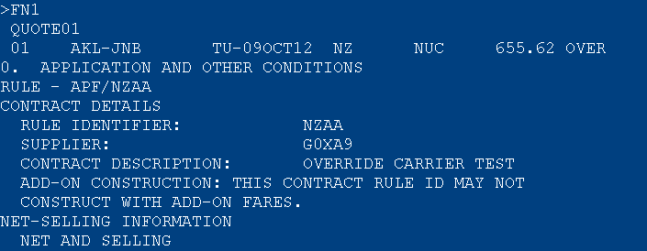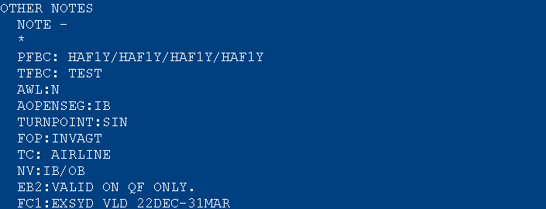

Eg. The script will use the value in the PFBC field to quote the published fare. The host entry for the above is FQS1@HAF1Y.2@HAF1Y.3@HAF1Y.4@HAF1Y. It then looks for a value in the TFBC field and in this case it will replace HAF1Y with the fare basis TEST.

|  |  |  |  |
| --- | --- | --- | --- |
| Accessing ATS An active PNR must be open on your screen before you access ATS. ATS will use the names and flights from this PNR when creating the fare.   * Retrieve PNR * Click on the ATS Icon from the toolbar     ATS is made up of 5 different screens.   * **Name Screen** - allows you to select the passengers for the quote * **Flight Screen** - allows you to select the segments and the pricing modifiers for the quote * **Fare Options Screen** – allows you to view alternative fares (optional screen) * **Update Screen** – displays the ticketing modifiers and allows you to make amendments if required * **Confirm Screen** - allows you to accept or cancel quote   The Custom Viewpoint window opens on the first screen, which is the Names screen. Each screen of ATS is explained in detail on the following pages. It is recommended to maximise the script, that way the full screen is visible, and scrolling will not be required.  The title bar displays the version of the script which is running, and this bar follows you throughout the script as you move through the 5 screens – Names, Flights, Fare Options, Update and Confirm. The screen name will be highlighted to show you the screen you are currently on.    You can exit the script at any time by clicking on the “Close Window” box or by clicking on the red “X” in the top right hand corner of the application. Navigation within the Script You can either TAB through the screen or use your mouse to click on the options. On each screen (excluding name screen) a **<<Back** button can be found, which will take you to the previous screen if required.   Name Screen This screen is used to update passenger information if required.  Any box with a tick can be selected or deselected by clicking on the tick box, depending on requirements.  Once the selection has been made you will need to click on **Next>>** to continue.    Please note: Due to CAT35 logic only passengers with the same PTC can be quoted by ATS. If you have different PTC’s you would need to select the passengers with the same code and continue. Then you would need to run ATS again for the other passenger types. **Passenger Selection** Any box with a tick can be selected or deselected by clicking on the box, depending on the requirements. If you want to re-select all passengers you can use the “All Names” tick box, located below the individual name boxes.  ATS will automatically select all passengers from your PNR and they will default as Passenger Code ADT unless you have specified a passenger type code PTC in the name field of your PNR.  Eg.      Due to CAT35 logic you would deselect Amy (child) by clicking on the tick box next to her name, then click **Next>>** to continue to the Flight Screen. |  |  | |
| Once the script has finished, you would need to run ATS again and select only Amy (child). **Adding/Amending a PTC**  If you haven’t specified a PTC (passenger type code) in your PNR you can add a passenger code from the Name screen. To do this you would need to specify the passenger and then use the drop down “Passenger Code” menu to select a different PTC.  Once you have opened the selection box you can type the first letter of the code you are looking for and the list will move to the codes starting with that letter. If you type the full code it will automatically highlight that code. You would then *click* on the code itself, or hit *TAB* to select it.     **Adding/Amending a child age** |  | |  | |

To change a Passenger Code with a numeric field eg. Child age, you firstly select the passenger to change, choose the PTC code from the drop down menu, then select the tick box (located at the end of the Drop Down Menu) and add the numeric age. When you click outside of the age box or press TAB the Passenger Code will automatically update. (See example below).

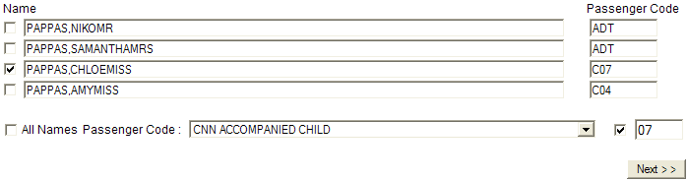

Once you have updated the passenger codes (if required) click on **Next>>** to continue.

# Flights Screen

This screen is used to add modifiers to the quote as required.

Any box with a tick can be selected or deselected by clicking on the tick box, depending on requirements.

Once the selection has been made you click on **<<Get Fare Quote>>** to continue.

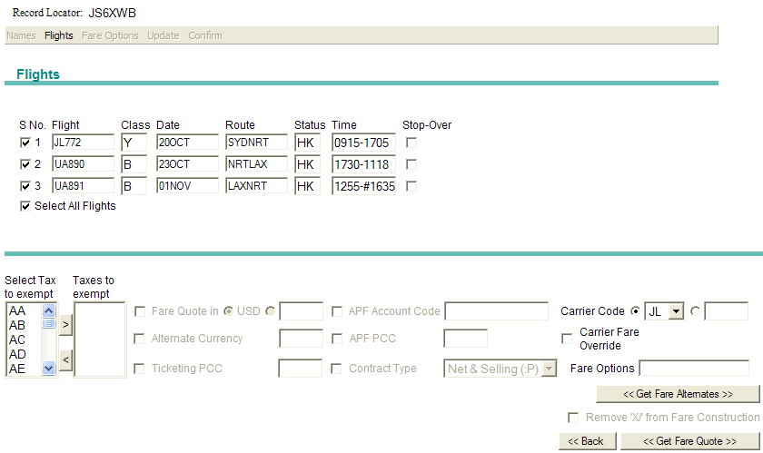

Once you click on **<<Get Fare Quote>>** the script will (behind the scenes) quote the fare. A prompt will be displayed to confirm the fare quote has been completed. You then click **OK** to continue.

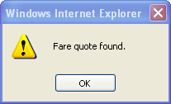

## **Flight Selection**

By default ATS will automatically select all flights from your PNR.

Eg.

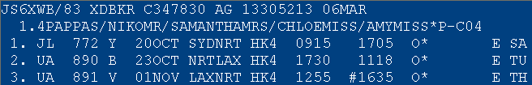

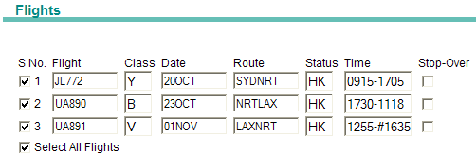

**Segment Select:** To de-select a flight you would click on the tick box of the unwanted segment. Eg. Based on the example below, the script will now quote Segments 2 and 3 only.

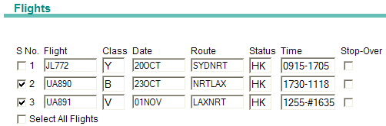

Host Example: FQP1*ADT.2*ADT.3*ADT/**S2.3**/CJL /ET

If you wish to re-select all flights at once you can use the “Select All Flights” tick box.



**Stopover:** The stopover box allows you to force in a stopover.

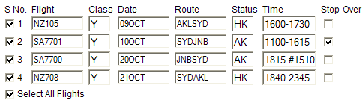

Host example: FQP1*ADT/S1.2.3.4/**O2**/CNZ/ET

## **Fare Quote Modifiers**

ATS allows you to select additional modifiers for the quote, if required. To activate the modifier boxes you need to select the field by putting a tick in the relevant box.

When you have finished adding the modifiers for the quote you would click **<<Get Fare Quote>>** to continue.

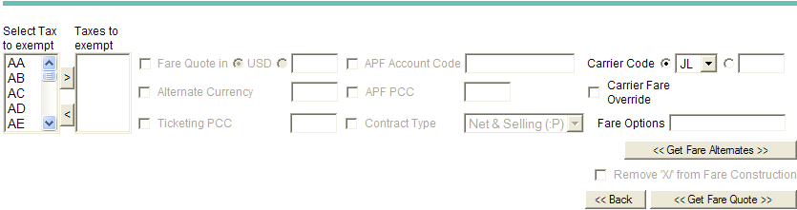

Below are detailed examples of each modifier and the equivalent host entry used when these are selected.

**Exempt Taxes**: Select the tax you wish to exempt and then click on the arrow to move it to the exempt column. The same process is used to remove the tax.

After clicking in the tax box you can start typing the tax code and the box will automatically move to the codes starting with that letter, or you can type the full tax code and this will then be highlighted.

Add: 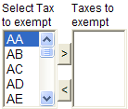 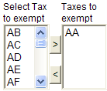 Remove: 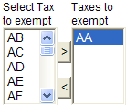 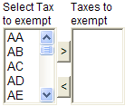

Host example: FQP1*ADT.2*ADT.3*ADT/S2.3/CUA/**TE-UO**/ET

**Currency for the Quote** – To activate this modifier you must first put a tick in the box, it will then default to USD. This can be changed by using the radio button on the right of USD to type your own choice.

 or 

Host example: FQP1*ADT.2*ADT.3*ADT/S2.3/CUA**:USD**/ET or FQP1*ADT.2*ADT.3*ADT/S2.3/CUA**:AUD**/ET

**Alternate Currency for the Quote** – To activate this modifier you must first put a tick in the box, then add the currency you wish to quote.



Host example: FQP1*ADT.2*ADT.3*ADT/S2.3/CUA**::JPY**/ET

**Ticketing PCC** – To activate this modifier you must first put a tick in the box, then add the applicable Pseudo City Code.



Host example: FQP1*ADT.2*ADT.3*ADT/S2.3/CUA/**TAXD8**/ET

**APF Account Code** – To activate this modifier you must first put a tick in the box, then add the applicable account code into the text box.



Host example: FQP1*ADT.2*ADT.3*ADT/S2.3/CUA/-**combi/**ET

**APF PCC** – To activate this modifier you must first put a tick in the box, then add the applicable Pseudo City code where the Agency Private Fare is loaded.



Host example: FQP1*ADT.2*ADT.3*ADT/S2.3/CUA**/-combi*xa5**/ET

**Contract Type** – To activate this modifier you must first put a tick in the box, then the type of fare from the dropdown menu. By default it will show Net & Selling.

 or 

Host examples : FQP1*ADT.2*ADT.3*ADT/S2.3/CUA**:P**/ET or FQP1*ADT.2*ADT.3*ADT/S2.3/CUA**:C**/ET

**Plating Carrier –** To activate this modifier you must first put a tick in the box. By default the first outbound carrier will generate into this field. This can be overridden by using the drop down menu to select an alternative carrier already in your itinerary or by selecting the radio button and adding a different carrier.

 or  or 

Host examples:

FQP1*ADT.2*ADT.3*ADT/S2.3/**CJL**/ET

FQP1*ADT.2*ADT.3*ADT/S2.3/**CUA**/ET

FQP1*ADT.2*ADT.3*ADT/S2.3/**CUA**/ET

**Override Carrier** – To activate this modifier you must put a tick in the box. The script will use the airline from the Carrier Code as the override carrier. This field also allows you to add a plating carrier if required. To do this, you need to add the carrier code into the plating carrier text box.

Standard Override

 Host Entry: FQP1*ADT.2*ADT.3*ADT/S2.3/**OCJL**/ET

Standard Override with Plating Carrier

 Host Entry: FQP1*ADT.2*ADT.3*ADT/S2.3/**OCJL/CUA**/ET

Change the carrier code and use the override entry

 Host Entry: FQP1*ADT.2*ADT.3*ADT/S2.3/**OCUA** /ET

Change the carrier code, use the override entry and add a plating carrier

 Host Entry: FQP1*ADT.2*ADT.3*ADT/S2.3/**OCUA/CJL**/ET

**Get Fare Alternatives** – Allows agents to search for alternative fares using the FQA entry. If a fare alternative is found the fare options screen is opened.

 Host example: **FQA**P1*ADT.2*ADT.3*ADT/S2.3/CUA/ET:P

# Fare Option Screen

This screen is displayed when the alternative fares button is pressed from the flight screen. It displays a list of the alternative fares on screen.

## **Fare Alternative**

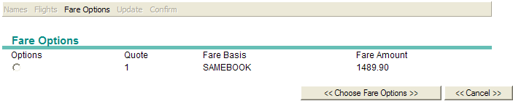

The agent would select the fare by clicking on the appropriate radio button, then click on the **<<Choose Fare Options >>** button.

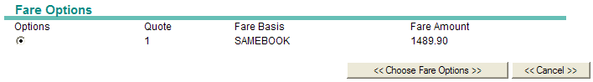

The Fare option screen is then closed and the fare basis selected is generated into the “Fare Options” field on the flight screen.



Host example: FQP1*ADT.2*ADT.3*ADT/**S2@SAMEBOOK.3@SAMEBOOK**/CUA/ET

## **Combination Fares**

When ATS determines a combination fare has been quoted it will compare the following fields and if they are found to be different it will display the “Select Rule” screen.

The agent would compare the fare rules side by side, then manually choose which fare rules to apply.

* + AOPENSEG - Open Segments
  + FOP - Form of Payment
  + CFOP - Combination Form of Payment
  + NR - Net Remit
  + NV - Validity Dates
  + EB2 - Endorsement field
  + FC1 – FC3 - Fare Calculation Line
  + CTC - Combination Tour code

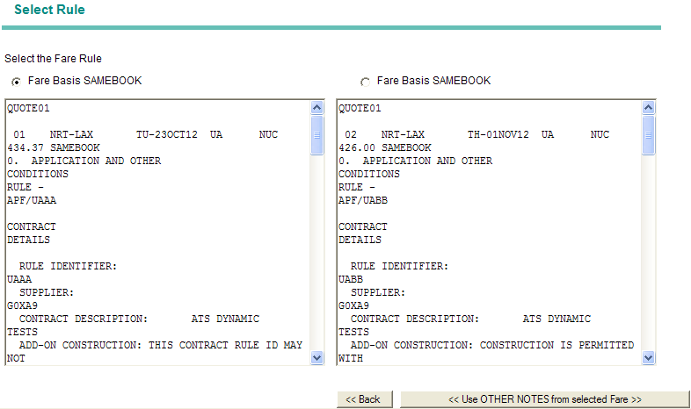

In the above example the combination form of payment is different.

APF/UAAA APF/UABB

CFOP:CK CFOP:S

Therefore the agent would need to choose which form of payment to use. Eg. If they select Fare 1 then the form of payment will be Cheque, if they select Fare 2 then the form of payment will be Cash.

The fare is selected by clicking on the appropriate radio button, then clicking on the **<<Use OTHER NOTES from selected Fare>>** button. A prompt will be displayed to confirm the fare quote has been completed. The agent clicks **OK** to continue.



Please note: If these fields are the same this step is skipped and you are taken straight to the “Update” screen.

**Remove X from Fare Calculation Line** – To activate this modifier you must put a tick in the box, this will then generate a fare construction section to appear on the Update Screen after you click on the **<<Get Fare Quote>>** button.



The fare calculation line is displayed on the Update Screen with boxes over the transfer locations. Eg. X/SYD. You would then put a tick in each of the box to remove the transfer icon X/SYD, as per your requirement.

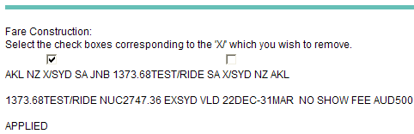

New fare calculation line with the 1st transfer changed to a stopover:



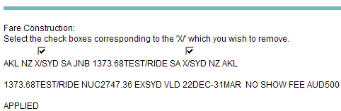

New fare calculation line with both transfers changed to a stopovers:



# Update Screen

This screen allows agents to amend fields if required. Any box with a tick can be selected or deselected by clicking on the box, depending on your requirements.

Changes are not normally required as the data is pre-populated by the script, however changes can be made to the flight data and the ticket modifiers if needed.

When you have finished adding ticket modifiers you would click **<<Press Here To Update>>** to continue.

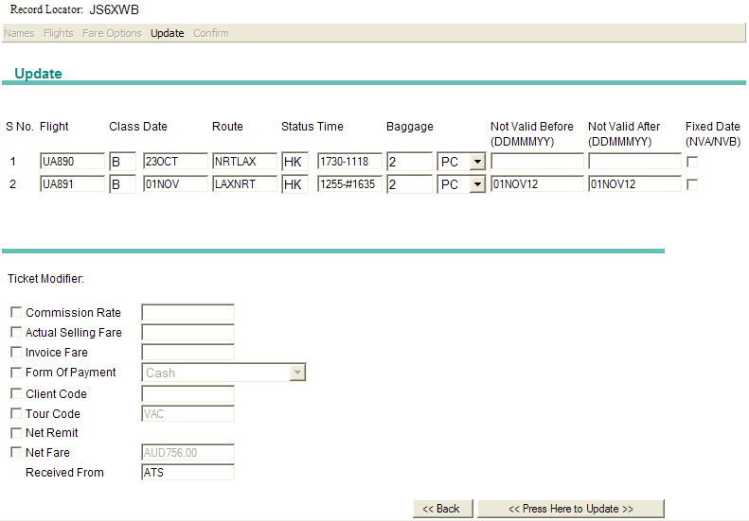

Please Note: Any changes made will be recorded in the historical Notepad field of the PNR for reference.

## **Flight Data**

ATS only allow you to update Baggage & Validity Dates, however as these are auto generated it is not normally required.

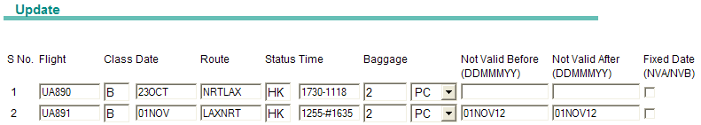

**Baggage –** this fieldallows for the Piece / Kilo and new IATA CHK field, by using the drop down list.

  

Host examples: FBUBG2/1PC / FBUBG1/20K / FBUBG1/CHK

**Validity Dates –** this field allows you to change dates by manually typing in the field or using the tick box to default to travel dates.

 or

Host examples: FBUNVA1/23OCT12 / FBUNVB1/23OCT12 / FBUNVA2/01DEC12 / FBUNVB2/01DEC12

## **Ticket Modifiers**

ATS allows you to update all of the following fields, however as these are auto generated by the script it is not normally required.

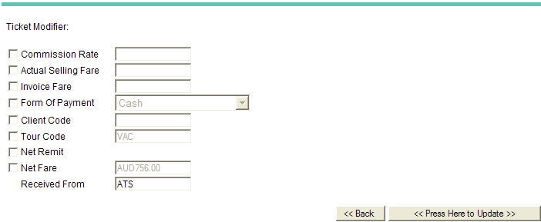

Below are detailed examples of each modifier and the equivalent host entry used when these are selected.

**Commission Rate –** To activate this modifier you must first put a tick in the box, then add the appropriate commission level into the text box. If the commission is stored in the APF fare this field will not be displayed.



Host Example: TMU1**Z5**

**Actual Selling Rate** **–** To activate this modifier you must first put a tick in the box, then you can add the actual selling fare value into the text box.



Host Example: TMU1**ASF200.00**

**Invoice Fare** **–** To activate this modifier you must first put a tick in the box, then you can add the invoice fare value into the text box.



Host Example: TMU1**IF200.00**

**Form Of Payment (FOP)** – To activate this modifier you must first put a tick in the box, then you can choose a form or payment from the drop down menu.

 Host Example: TMU1**FS**

 Host Example: TMU1**CK**

The following form of payments allow additional information to be added if required.



Host Example: TMU1**FINVTEST**



Host Example: TMU1**FNONREFTEST**



Host Example: TMU1**FVIXXXXXXXXXXXX3333*D1012**



Host Example: TMU1**FMSTEST**

**Client Code** – To activate this modifier you must first put a tick in the box, then you can add client code into the text box.



Host Example: TMU1**CD-123**

**Net Remit** – To activate this modifier you must first put a tick in the box.



Host Example: TMU1**NR**

**Tour Code** – To activate this modifier you must first put a tick in the box, then you can change/amend the tour code if required.



Host Example: TMU1**TCVAC**

**Net Fare** – To activate this modifier you must first put a tick in the box, then you can change/amend the net fare value if required.



Host Example: TMU1**NFAUD756.00**

**Received From** – By default this field will show ATS, however this can be changed if required



Host Example: R.**ATS**

When you have finished adding your ticket modifiers you would click **<<Press Here To Update>>** to continue.

# Confirm Screen

This screen displays the Filed Fare.

Please note: This screen is designed to focus on the filed fare initially, therefore to view the header the agent would need to scroll up.



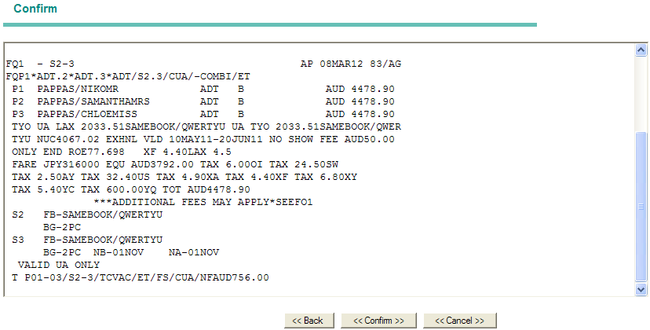

After reviewing the fare the agent can either:

1. Go Back **<<Back**, to return to the previous screen and make changes if required
2. Accept the fare **<<Confirm>>,** to save the filed fare and exit the script
3. Cancel **<<Cancel>>,** to cancel the filed fare.
   1. If you select **Cancel**, a prompt is displayed asking you to confirm your choice

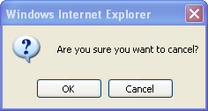

* + 1. If you select **Cancel**, the confirm screen is redisplayed
    2. If you select **OK**, a 2nd prompt is displayed asking if you would like to retry the fare quote

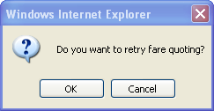

* + - 1. If you select **OK**, the name screen is displayed
      2. If you select **Cancel**, the script is closed

# PNR

The script will enter a Notepad history remark for all TMU and FBU commands. The script will mask the net fare data in the notepad field if the agent using ATS is not the same as the creating agent of the booking file.

***** NOTEPAD HISTORY JS6XWB *****

XNP H* ATS NP ENTRY START 83 08MAR 1114Z

XNP H* ATS FBUFC/TYO UA LAX 2033.51SAMEBOOK/QWERTYU UA TYO 2033.

51SAMEBOOK/QWERTYU NUC8308MAR1114Z

XNP H* ATS 4067.02 EXHNL VLD 10MAY11-20JUN11 NO SHOW FEE AUD50.0

0 ONLYBO83/08MARY1114Z

XNP H* ATS FBUFARE/JPY316000 83 08MAR 1114Z

XNP H* ATS FBUEQ/AUD3792.00 83 08MAR 1114Z

XNP H* ATS FBUTTL/ 83 08MAR 1114Z

XNP H* ATS FBUEB/ VALID UA ONLY 83 08MAR 1114Z

XNP H* ATS FBUNVA2/01NOV12 83 08MAR 1114Z

XNP H* ATS FBUNVB2/01NOV12 83 08MAR 1114Z

XNP H* ATS TOUR CODE- ORIGINAL VAC MODIFIED VASE 83 08MAR 1114Z

XNP H* ATS TMU1TCVASE 83 08MAR 1114Z

XNP H* ATS NET FARE- ORIGINAL AUD756.00 MODIFIED AUD700.00 83 0

8MARL1114Z

XNP H* ATS TMU1NFAUD700.00 83 08MAR 1114Z

XNP H* ATS FORM OF PAYMENT - ORIGINAL S MODIFIED N/A 83 08MAR 1

114Z

XNP H* ATS TMU1FS 83 08MAR 1115Z

XNP H* ATS NP ENTRY END 83 08MAR 1115Z

As mentioned earlier if the agent manually updates the ticket modifiers it is reflected in the notepad history.

Eg. ATS NET FARE- ORIGINAL AUD756.00 MODIFIED AUD700.00